NA-HA-SHNEE NATIVE AMERICAN HEALTH SCIENCE INSTITUTE
For Native American students interested in medicine, nursing, pharmacy, nutrition, and other health careers.
June 18th – 29th, 2018

What is Na-ha-shnee? Na-ha-shnee is a 12 day summer program designed to encourage Native American and Alaska Native students to pursue health science degrees and health-related careers. The program is held on the WSU Spokane Campus and housing is in nearby dorms. Participants gain hands-on training in basic skills as a health professional, college preparation experience, and cultural activities during this summer-camp structured program.
Who should apply? Native American and Alaska Native students that are currently in 9th, 10th, or 11th grade. Applicants should have a GPA of 3.0 or above and an interest in health science careers (nursing, medical research, nutrition, physical therapy, medicine, pharmacy, physical therapy, dentistry, etc.).
Where is the application? Applications can be filled out and submitted online. This application can be found online at: https://wsu.co1.qualtrics.com/jfe/form/SV_exoNCAB69Z9f8Z7 (Or google WSU Native American Health to find it on our website). A pdf/hard copy of the application can be requested by emailing emma.noyes@wsu.edu.
What does it cost? Thanks to generous donations from tribes and WSU partners, this program is FREE. The only cost that we cannot cover is transportation to and from our program. We do not have any travel stipends.
DEADLINE FOR APPLICATION: 12 PM, Monday, APRIL 16th, 2018
Questions? Feel free to contact Emma Noyes, Native American Outreach Coordinator
Phone: 509.324.7215 Email: emma.noyes@wsu.edu Fax: 509.324.7341
This exciting summer opportunity is brought to you by:

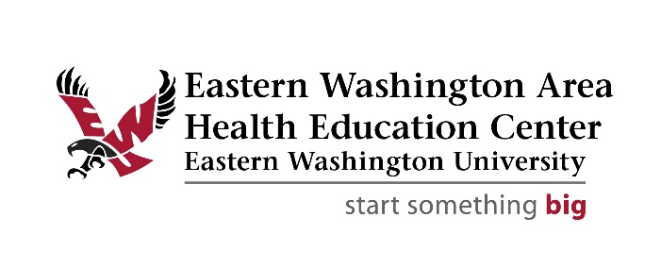
Frequently asked questions by parents and applicants:
Where will students be staying overnight and how will they be supervised? Students stay in a dorm on the Gonzaga University campus which is walking distance to our WSU Spokane campus. Each student is assigned a roommate and a room on either the female floor or the male floor of the dorm. Students are supervised by “camp counselors”, including two staff that are hired specifically to ensure that curfew is kept and students are safe.
Do I need to be enrolled in my tribe to attend? No, you do not need to be enrolled in your tribe to attend. In the application you are asked if you are enrolled or a descendant of a tribe. You do not need to provide documentation of your enrollment.
Can students leave with parents or guardians during the institute (example: attending local events, tournaments, practices, jobs, or family events)? Such a good question! The Na-ha-shnee Native American Health Science Institute involves a full schedule of college preparation, career exposure, leadership development, and getting to know mentors and other students. For this reason the institute is a closed campus program. Students may not miss any portion of the institute.
What if my student needs medical attention during the institute? Our staff includes a registered nurse that is available around the clock to administer prescription medications that students bring with them to camp. The nurse can also provide over the counter medications with parent permission, respond to any sports/accidental injuries, and determine whether further medical attention is needed. If further medical attention is needed parents/guardians will be contacted and student will be taken to the hospital. All hospital fees are the responsibility of parents/guardians.
What kind of activities take place at camp? Each day is packed with hands-on activities. These include CPR/First aid training, basic nursing skills, creating compounds in the pharmacy lab, medical school activities, group games, group fitness, cultural arts, visiting a human anatomy lab, sleep research labs, putting everything that you learn to the test in our simulation lab, and much more!

