2018 Steh-Chass Native Youth Camp
Monday August 27th 10-5 pm.
Tuesday August 28th 10-5 pm.
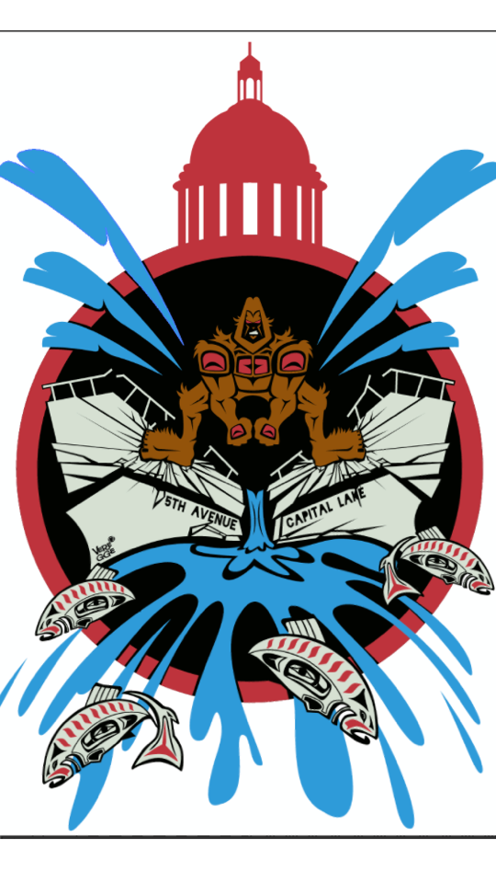

Registration Form
Student Information
Name_____________________________ Age________
School____________________________ Grade______
Tribe___________________________________________
Address_____________________________________________________
City_________________ State_____________ Zip______________
Youth Shirt Size
- Small
- Medium
- Large
- X Large
Phone Number _______________________________________________
Email Address________________________________________________
Parent or Guardian Information
Name_______________________________________________________
Address_____________________________________________________
Home #______________________ Cell #__________________________
Email Address________________________________________________

Emergency Contact (Check Yes if Same as Above)
Emergency Contact Name______________________ Relation__________
Phone # ______________________________________________________
I Give Consent for My Child Consent to Participate in a Survey Provided by the Potlatch Fund____________
I Give Permission to Call an Ambulance (911) in the Event of an Emergency______________
Both camp days will be held in Olympia and teach Native culture, history of the area, water quality testing, traditional plants, and crafts. Students will have the chance to present their work at the culminating Festival of the Steh-Chass September 1st at Heritage Park.
August 27th- Tumwater Historical Park 802 Deschutes Way SW, Tumwater, WA 98501
August 28st Heritage Park (Olympia) 5th Ave SW, Olympia, WA 98501

Youth Signature____________________ Parent/Guardian Signature______________________
To Register: Submit form to ajohnson@salmondefense.org or Contact Ali Johnson at (360) 791-3775

